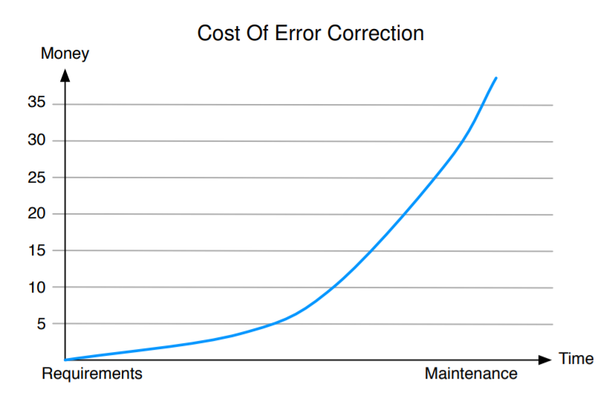**What is software quality?**   
Simple answer: Software should meet its specification.   
What about:   
I Usability?   
I Efficiency?   
I Reliability?   
I Maintainability?   
I Portability?   
I Reusability?

Techniques Of Validation And Verification Targeted At High-Quality Products   
I Testing  
I Formal verification   
I Test case generation   
I Model-checking  
I Simulation   
I Visualization  
  
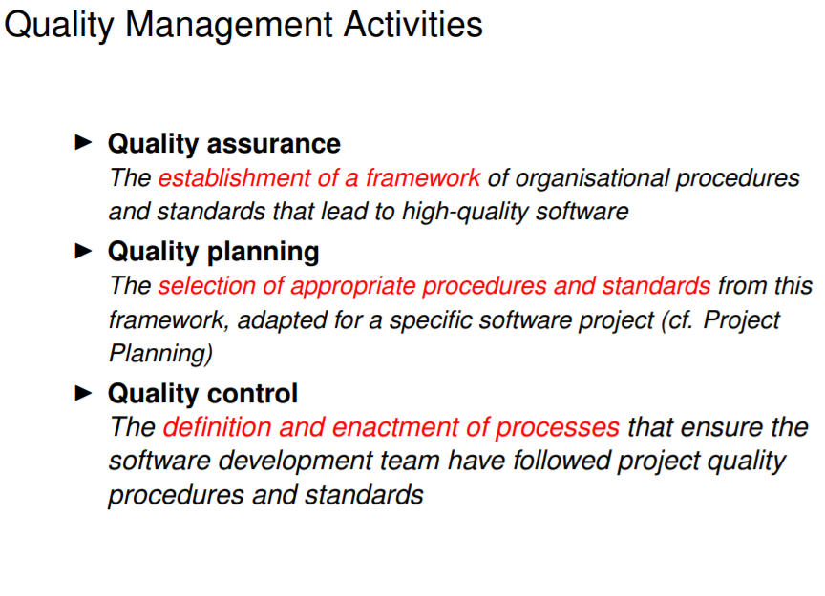  
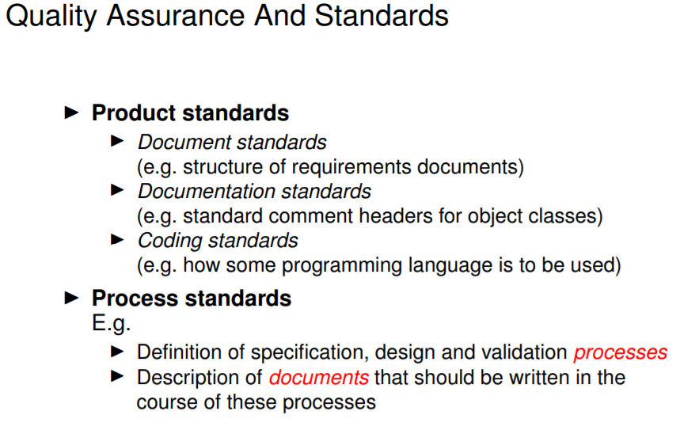  
Software standards   
I record best practices   
I help to avoid repeating past mistakes   
I provide basis for quality assurance process   
I assist in continuity and conformity among staff   
I reduce learning effort when starting new work  
  
**Attributes:**  
Safety Understandability Portability Security Testability Usability Reliability Adaptability Reusability Resilience Modularity Efficiency Robustness Complexity Learnability  
  
**Quality control: Inspection and reviews  
  
Process improvement**

**Process improvement**

The processes are evaluated after or during the product development using questionnaires and interviews. There are several process characteristics that are observed:

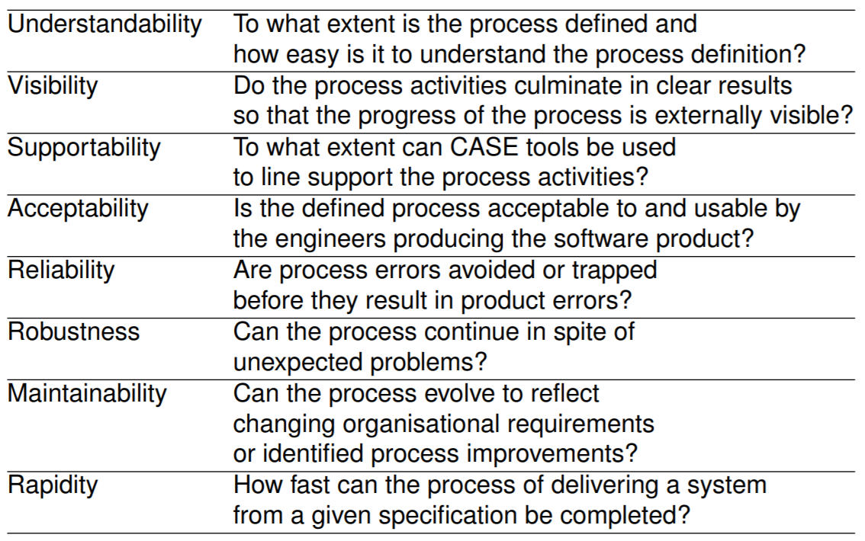

The cycle of process improvement goes like this:

1. Measure - observe the process.
2. Analyse the measurement results.
3. Change - design improvements based on the analysis.

